Name:  Class: | ____________________________________  ________________ | Date:__________
 | Year 11 Foundation Mathematics  Probability Investigation  1 Lesson  RESOURCES: Book, One Dice, Calculator | / 29  10%

- The chance of getting six is ‘one in six’ ( about 16.5%). [1,2,2 = 5 Marks]
  - What does this really mean?

  - Do you expect to get a six in the first six throws? circle your answer Yes No
Why?

  - Do you expect to get more than one six in the first six throws? Circle your answer Yes No
Why?

2. Use numbers to predict: [2,2 = 4 Marks]
a. About how many sixes would you expect to get in eighteen throws? ____________
Why?

b. About how many sixes would you expect to get in thirty throws? _______________
Why?

[9,1 = 10 marks]
- Roll the die and record the total number of sixes after six, eighteen, then thirty throws.
a. Combine the totals at your table and work out the percentage of throws that resulted in six.
Record the results below:
Number of throws | Tally | Number of sixes rolled | Percentage of throws that were six
6 throws |  |  | $\frac{}{6}$x 100 = ___________%
18 throws |  |  | $\frac{}{18}$x 100 = ___________ %
30 throws |  |  | x 100 = ___________%
b. How did each set of rolls compare to the expected 16.5%?

[1,2,2,1,1,1,1,1 = 10 Marks]
4. If there are 24 people on a footy team, and only 16 available spots for playing;
a. what is the chance you will get picked for the team? (leave your answer as an simplified fraction)

- Because of the chance of being picked, we can use a dice to simulate your selection. If there are 20 games in a season, choose and write in the space two numbers on the dice to represent not getting picked, and the other 4 as getting picked.
Picked:_____, _____, _____, _____,

Not picked: _____, _____,
- Roll the dice to simulate the season and record the results below
1 | 2 | 3 | 4 | 5 | 6 | 7 | 8 | 9 | 10
11 | 12 | 13 | 14 | 15 | 16 | 17 | 18 | 19 | 20

- How many games did you play?

- What fraction of games did you play?

b.. Given the weather below, and If you are playing football on Sunday, do you think your parents should bring a jacket to watch the game?
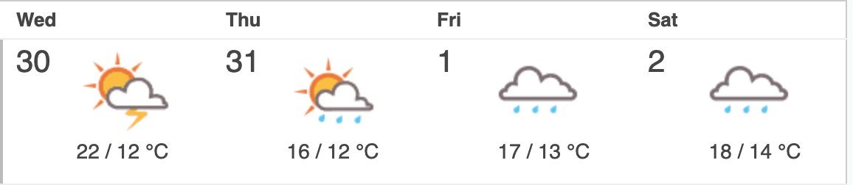

- How many days has it rained so far?

- How would you describe the chance of rain?

- Should your parents bring a jacket?

End of assessment

